

REPORT ON SHORT-TERM PROJECT WITH ALVRON PARTNERS



Submitted by: Saunak Rath
Roll No. – 24DM256
Section – D

Submitted To – Dr Anupama Singh
Date of Submission: 31st January 2025

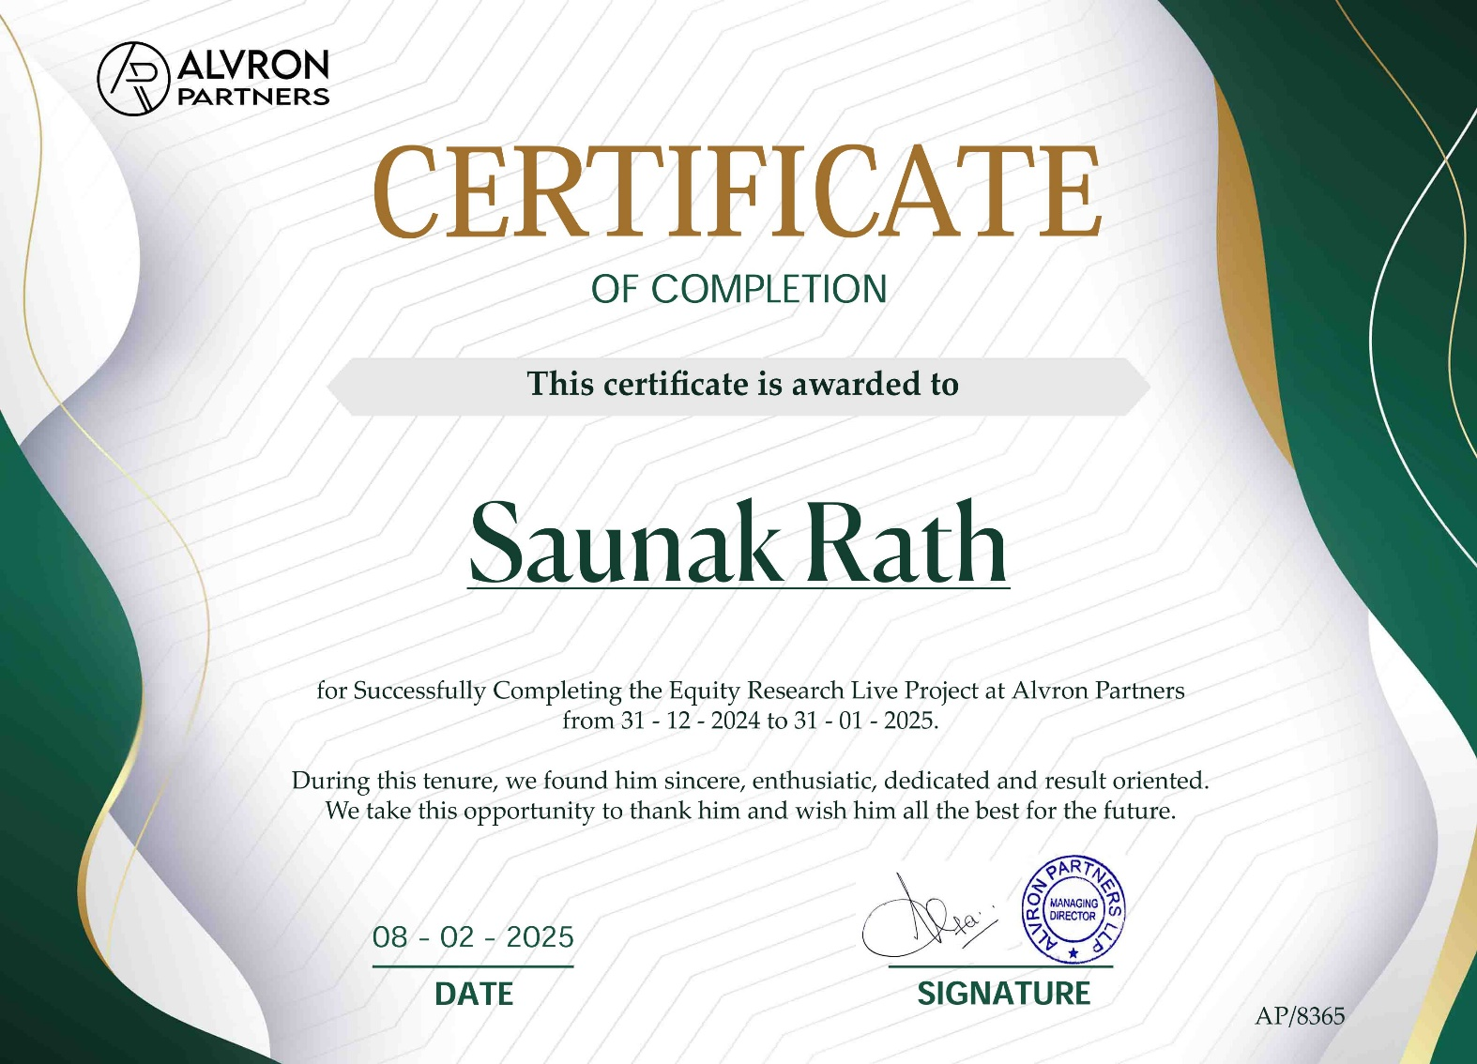

Executive Summary
This report presents an overall detail of my Short term project with Alvron Partners - a prestigious investment banking company. The project was developed for providing practical exposure to financial analysis and modelling. It was practiced for seven solid sessions: they encompassed the understanding of company financials; market behaviour, trading principles, and nuances of creating the financial model. The sessions provided me with the knowledge necessary to the financial data analysis and developed model building.
The very core of the project was to prepare financial model for Maruti Suzuki, pointing out its financial performance and intrinsic valuation. Tasks were that I was supposed to prepare the forecasted Balance Sheet and Profit & Loss of the company; the next was to create a revenue model and various schedules like Capex, debt, working capital schedules, etc.; further, calculated Weighted Average Cost of Capital (WACC) and completed a Discounted Cash Flow (DCF) valuation.
This project has allowed me to gain firsthand experience in analysing historical data to search for trends in the data-perceived future realistic assumptions, validity of financial schedules that render good judgment for investment decision-making. It helps calculate operational efficiency, market potential, as well as problems like debt management and the profit margin.
The structured training sessions followed by the application of theoretical knowledge in practical scenarios greatly improved my understanding of financial modelling. This report embodies my observations, analysis, and subsequent recommendations, along with a base of the financial model of Maruti Suzuki, highlighting the key areas of innovation in the company, operational efficiency, and debt optimization expected to generate sustainable growth.

Table of Contents
S No. | Particular | Page
1. | Title Page | 1
2. | Certificate Issued by the Organisation | 2
3. | Executive Summary | 3
4. | Table of contents | 4
5. | About Alvron Partners | 5
6. | About Maruti Suzuki | 7
7. | Introduction to Problem | 9
8. | Observation, Analysis and Discussion | 10-35
9. | Summary | 36
10. | Appendices | 36

Brief Introduction to the Company
Alvron Partners
Alvron Partners is a boutique investment banking firm specialize in raising capital for financial institutions. As a part of its advisory services, it assists its clients by providing wealth and investment management consultancy.
Firm assists its clients to achieve superior results through innovative and integrated financial advisory services. Dedicated and experienced team at Alvron support clients on their most crucial decisions including mergers & acquisitions, recapitalizations, strategic shareholder advisory, and other corporate finance matters.
Founded by former investment bankers at J.P Morgan and Goldman Sachs, the firm is headquartered in Mumbai.
Key Areas of Expertise:
- Financial Advisory Services:
Alvron Partners specializes in developing tailored financial models, capital structuring strategies, and valuation analyses to help businesses make informed decisions.
- Mergers and Acquisitions (M&A):
The firm provides end-to-end M&A advisory services, including deal structuring, due diligence, negotiation, and integration support, enabling clients to unlock synergies and drive value creation.
- Capital Markets Advisory:
Alvron Partners assists clients in raising capital through equity, debt, and hybrid instruments, ensuring optimal funding solutions for growth and expansion.
- Strategic Consulting:
The firm offers strategic insights to enhance operational efficiency, identify growth opportunities, and mitigate risks in a rapidly evolving business landscape.
- Sustainability and ESG Advisory:
Recognizing the growing importance of environmental, social, and governance factors, Alvron Partners supports businesses in integrating sustainability into their financial and operational strategies.

Industries Served:
Alvron Partners has extensive experience across a range of sectors, including:
- Manufacturing and Industrials
- Financial Services
- Technology, Media, and Telecommunications
- Infrastructure and Real Estate
- Energy, including Renewable Energy
- Healthcare and Pharmaceuticals
- Commitment to Excellence

Alvron Partners is dedicated to fostering long-term relationships with its clients by delivering measurable results. The firm’s goal is to empower businesses to thrive in an ever-evolving global economy, addressing challenges with agility and foresight.

By partnering with Alvron Partners, businesses gain access to a wealth of expertise, innovative solutions, and actionable insights, making the firm a trusted ally in achieving sustainable growth and creating lasting value for all stakeholders.

About Maruti Suzuki
Summary: Maruti Suzuki India Limited (MSIL) is a market leader in the Indian automotive sector, delivering strong financial performance through its portfolio of affordable and fuel-efficient vehicles. Established in 1981 as a joint venture between the Government of India and Suzuki Motor Corporation, the company has become a wholly owned subsidiary of Suzuki. Maruti Suzuki’s robust revenue streams stem from its diverse product mix, catering to various market segments, and its extensive dealership network across India.
Industry Landscape: The Indian automotive industry contributes significantly to the country’s GDP and is characterized by high competition among domestic and multinational corporations. The sector is undergoing structural shifts, with increasing capital expenditure (CapEx) on electric vehicles (EVs), stringent regulatory compliance costs, and shifting consumer demand influenced by macroeconomic indicators. The industry’s growth trajectory is supported by rising disposable incomes, government incentives for manufacturing, and tax benefits for green technologies. Key risks include volatility in raw material prices, currency exchange fluctuations, and supply chain disruptions.
Key Developments in the Last Five Years:
- Electric Mobility Investments: Maruti Suzuki has announced significant capital allocations towards EV development, targeting its first EV launch by 2025. Strategic partnerships with Toyota enhance economies of scale and technology sharing for hybrid and electric platforms.
- Sustainability Expenditure: The company has increased operating expenditure (OpEx) on sustainability initiatives, including Smart Hybrid Vehicle by Suzuki (SHVS) technology and factory-fitted CNG options, enhancing its ESG (Environmental, Social, Governance) compliance.
- Technological R&D Spending: Maruti Suzuki has invested in advanced R&D for connected car technologies, exemplified by the rollout of Suzuki Connect, which integrates real-time telematics and data analytics.
- Infrastructure Expansion: To meet growing demand, the company has scaled production capacity through CapEx in new manufacturing plants, such as the Gujarat facility, and expanded its distribution channels, targeting high-margin rural markets.
- Product Portfolio Diversification: Launching new models and upgrading flagship products like Swift, Baleno, and Brezza have bolstered market share, driving revenue growth and customer acquisition.

Focus of Projects: Maruti Suzuki prioritizes projects with high return on investment (ROI), focusing on:
- Green Mobility: Developing low-emission vehicles and EVs to mitigate carbon footprint while tapping into government subsidies and tax incentives.
- Enhanced Safety Standards: Incorporating advanced driver-assistance systems (ADAS) to comply with regulatory mandates and appeal to safety-conscious consumers.
- Cost Optimization: Streamlining production processes and sourcing strategies to manage input costs and maintain competitive pricing.
- Customer Engagement: Investing in digital transformation and subscription-based ownership models to increase customer lifetime value (CLV).
Significance of Mentors: Mentors serve as critical assets in driving organizational value, shaping strategic direction, and fostering human capital development. For Maruti Suzuki, mentorship programs enhance employee productivity and innovation, directly impacting the company’s financial performance and operational efficiency.
Role of Mentorship: Mentorship at Maruti Suzuki delivers tangible financial benefits through:
- Leadership Development: Grooming future leaders to ensure sustainable management succession, reducing turnover costs.
- Skill Upgradation: Training employees to enhance operational efficiency and align with emerging industry trends, driving productivity gains.
- Innovation Facilitation: Encouraging R&D-driven initiatives that contribute to product differentiation and market expansion.
- Cultural Cohesion: Supporting integration and alignment of new hires with organizational values, minimizing onboarding costs.
- Knowledge Management: Leveraging institutional knowledge transfer to reduce redundancy and improve decision-making, enhancing overall profitability.
In summary, Maruti Suzuki’s strategic investments in innovation, sustainability, and talent development, coupled with a structured mentorship framework, have positioned the company for sustained growth and value creation in India’s competitive automotive landscape.
Introduction to Problem
The underlying intent of the project was to bridge the gap between theoretical financial understanding and its practical application, especially through the financial modelling aspect. Such an undertaking was called to life with a view to creating a complete financial model for Maruti Suzuki, capable of forecasting correctly the financial performance and intrinsic value of the company.
The project necessitated this kind of understanding, as it would transport students such as myself from the abstract grounds of financial principles into their concrete application. In the process, this research started by examining the history of Maruti Suzuki financial data to determine trends and patterns, which provided the basis for the projection of future company performance.
It also included the relevant, detailed schedules that would underpin the financial modelling exercise, such as:
CapEx Schedule: Elucidating the continuous schedule or investment programming by funding.
Debt Schedule: Repayment, disclosure of credit behavior with time, and monitoring of total borrowing.
Working Capital Schedule: To estimate the operational liquidity.
In addition, the project involves forecasting the key financial statements-the Profit and Loss Account (P&L), Balance Sheet, and Cash Flow Statement of the company based on realistic assumptions. Another critical component characterized by the estimation of the Weighted Average Cost of Capital (WACC), as this represents a benchmark of evaluation of the cost of funding.
The project finally summarized itself with a coverage of Discounted Cash Flow (DCF) to compute the intrinsic value of Maruti Suzuki and turning all these activities into an aligned and workable financial model.
Observations
Session 1: Introduction to Valuation Techniques and Financial Modelling
The primary objective of the first session was to equip participants with the fundamental principles of valuation methods and the construction of financial models. Using Happiest Minds as a case study, participants were introduced to the essentials of how these techniques help in assessing a company's value.
Valuation Principles:
Valuation is essential for understanding a company’s standing in the market. Key techniques include absolute valuation methods, such as Discounted Cash Flow (DCF) and the Excess Return Model, both of which emphasize estimating future cash flows and economic profits. While DCF is suitable for most companies, financial institutions like banks require the Excess Return Model for better accuracy.
Relative Valuation:
Using valuation multiples like P/E, EV/EBITDA, and P/B, we evaluated Happiest Minds relative to its peers in the industry, providing a benchmark comparison.
Sum of the Parts (SOTP):
This method focuses on valuing individual business segments, particularly in conglomerates, by evaluating them independently rather than as a whole.
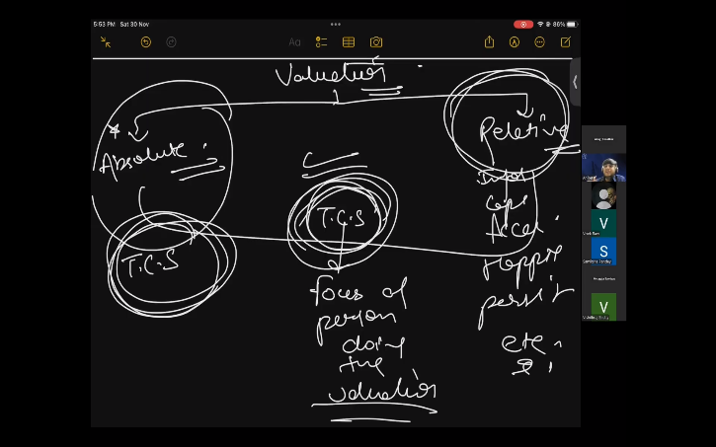
Linked Financial Model/Three-Statement Model:
The interconnectedness of the P&L, Balance Sheet, and Cash Flow Statement was examined to emphasize how these statements support financial forecasts and decision-making.
Insight:
The valuation frameworks used to assess Happiest Minds were found to be adaptable for other firms, such as Maruti Suzuki, by adjusting the techniques to suit industry-specific characteristics.

Session 2: Cash Flow Statement, Interlinkages, and Market Basics
This session focused on preparing and interpreting cash flow statements, while also introducing market concepts, using Happiest Minds as the case example.
Cash Flow Statement:
The cash flow components (operating, investing, and financing activities) were reviewed, highlighting that a positive operating cash flow indicates good operational efficiency, while negative investing cash flow signals growth-driven investments.
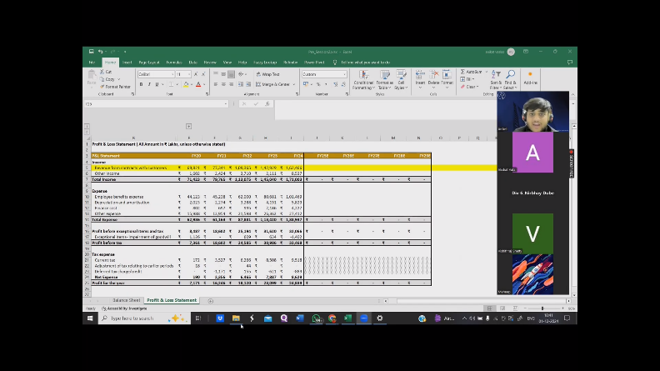
Financial Model Linkages:
We explored the linkages between critical financial data such as depreciation, interest, and working capital, and how they affect the three key financial statements.
Market Influences on Valuation:
The impact of macroeconomic factors, interest rates, and market sentiment on company valuations was discussed, using Happiest Minds’ market performance as an example.
Insight:
Participants understood the value of cash flow analysis for evaluating liquidity and the broader market factors that influence valuation—this insight was later applied to Maruti Suzuki.
Session 3: Developing a Revenue Model
The focus of this session was on creating accurate revenue forecasts, using Happiest Minds as an initial example, followed by its application to Maruti Suzuki.
Revenue Streams:
We examined the primary revenue drivers of Happiest Minds, including its digital services and cloud-based solutions. This approach was subsequently adapted for Maruti Suzuki, where revenue is generated from passenger vehicles, commercial vehicles, and electric vehicles (EVs).
Revenue Forecasting:
Using past data and market trends, we projected future revenue growth for both companies, focusing on sustainable growth patterns.
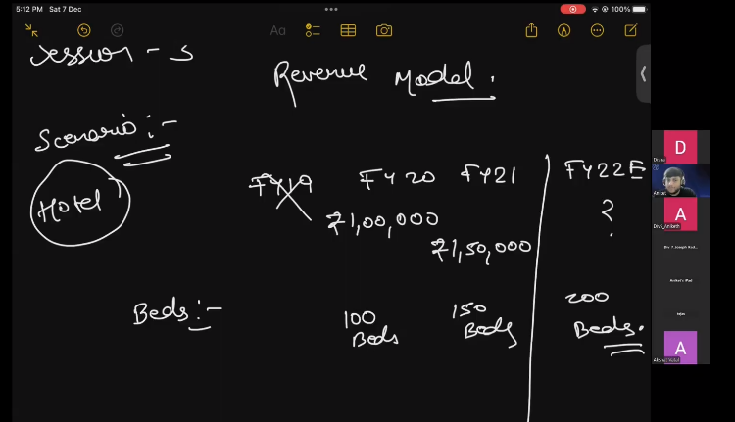
Insight:
The importance of validating assumptions through variance analysis was emphasized, which is essential for ensuring the reliability of revenue models when applied to companies like Maruti Suzuki.
Session 4: Developing a Capital Expenditure (CapEx) Schedule
This session centered around constructing and analyzing CapEx schedules, starting with Happiest Minds and later extending the analysis to Maruti Suzuki.
CapEx Allocation:We reviewed how Happiest Minds allocated funds for technological advancements and growth, then applied the same principles to Maruti Suzuki, particularly in relation to investments in electric vehicle (EV) technologies and infrastructure.
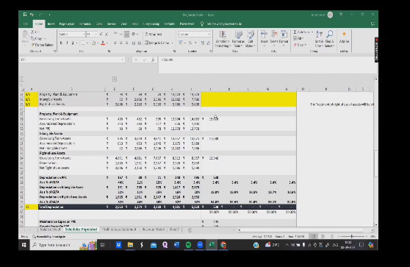
Insight:
Participants grasped the long-term strategic value of CapEx, highlighting the challenge of balancing short-term liquidity with long-term growth needs.
Session 5: Debt and Working Capital Management
This session introduced forecasting techniques for debt and working capital, initially based on Happiest Minds, and later applied to Maruti Suzuki for hands-on understanding.
Debt Management:
We explored how Happiest Minds structured its debt, with insights then applied to assess Maruti Suzuki leverage and financial health.
Working Capital Management:
The session covered the role of working capital components such as receivables, payables, and inventory in managing cash flow for both companies.
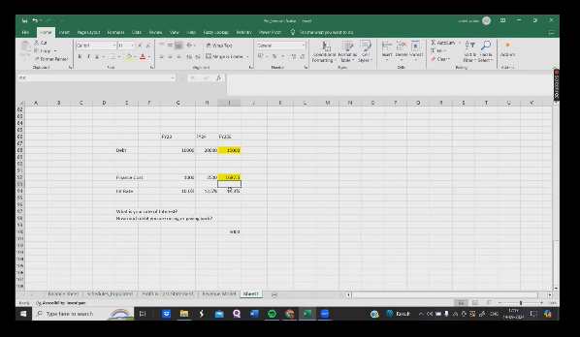
Insight:
The session reinforced the critical importance of efficient working capital management and appropriate debt structuring for maintaining financial stability across industries.
Sessions 6 & 7: WACC, DCF, and Relative Valuation
The final sessions provided more advanced training, integrating theoretical knowledge with practical applications, focusing on WACC, DCF, and relative valuation techniques.
WACC Calculation:
We calculated the Weighted Average Cost of Capital (WACC) for Happiest Minds, factoring in the cost of equity (via CAPM) and cost of debt. This was then applied to estimate the WACC for Maruti Suzuki.
Discounted Cash Flow (DCF) Valuation:
A DCF model was built for Happiest Minds, followed by a similar model for Maruti Suzuki, with assumptions such as growth rates and terminal value adjusted accordingly.
Relative Valuation:
The valuation multiples of Happiest Minds and Maruti Suzuki were compared and analysed in the context of their respective industries.
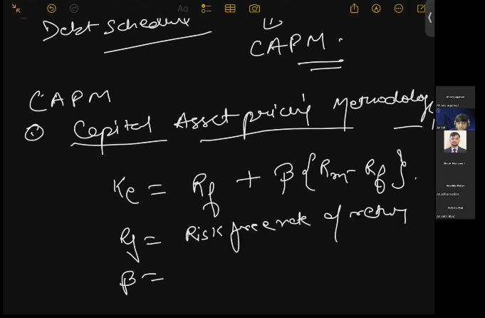
Insight:
These sessions highlighted the value of integrating quantitative analysis with the broader market context, providing participants with actionable insights for practical valuation applications.
Analysis
What is an Income statement?
The income statement indicates a company's financial performance measured over a reporting period. Performance is assessed by summarising how the business incurs its revenues, expenses and net profit or loss incurred over the period. It's also called the P&L statement.
Income Statement Forecasting & Analysis of Maruti Suzuki
(All Amount in Cr, unless stated otherwise)
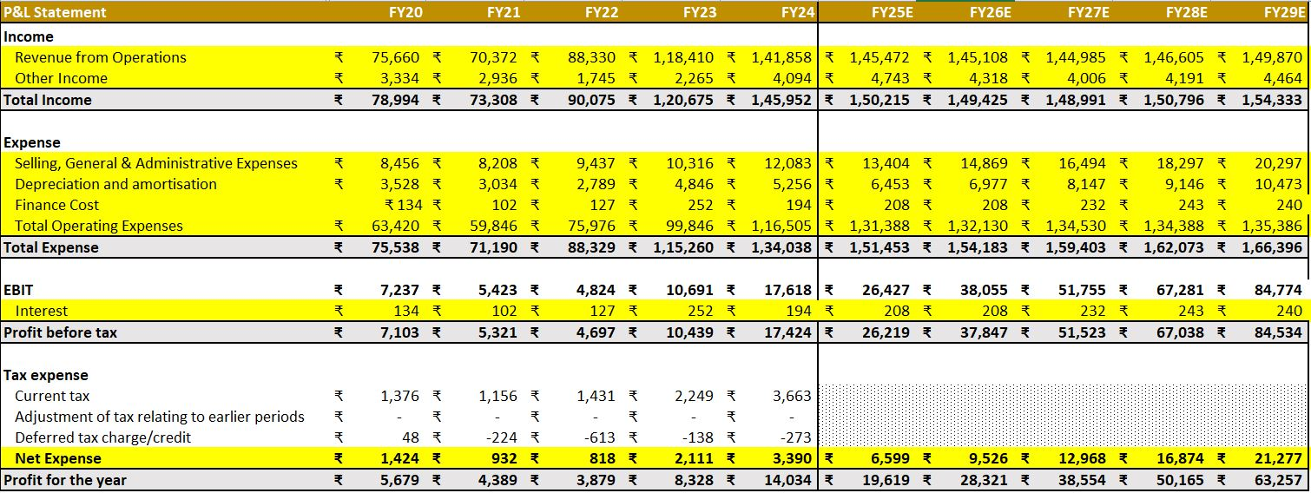
1. Analysis of Past Performance (FY20–FY24)
Revenue Growth: From ₹75,660 crore in FY20 to ₹1,41,858 crore in FY24, the company's operating revenue has increased steadily.
Expense Trends: Selling, general, and administrative (SG&A) costs as well as depreciation and amortisation have seen a proportionate growth in operating expenses.
Profitability: From ₹7,237 crore in FY20 to ₹17,618 crore in FY24, EBIT grew dramatically. Strong operational efficiency was demonstrated by the net profit, which increased from ₹5,679 crore in FY20 to ₹14,034 crore in FY24.
2. Forecast for the Future (FY25E-FY29E)
Revenue Projection: It is projected that revenue will rise from ₹1,45,472 crore in FY25 to ₹1,49,870 crore in FY29 at a compound annual growth rate (CAGR) of about 6%.
Expense Growth: While cost-cutting measures are increasing profits, operating costs are still rising.
Profit Growth: EBIT is expected to increase from FY25's ₹26,427 crore to FY29's ₹84,774 crore.
It is anticipated that profit before taxes will increase from ₹26,219 crore in FY25 to ₹84,534 crore in FY29. In FY29, net profit is anticipated to reach ₹63,257 crore, demonstrating strong financial standing.
3. Key Takeaways & Strategic Outlook
Diversification of Revenue: Strong brand value and consumer demand are indicated by steady revenue growth.
Cost Control & Efficiency: Effective cost control is boosting profit margins.
Robust Financials: The company is appealing to investors due to its significant increasing trends in EBIT and Net Profit.
What is a Balance sheet?
A balance sheet lists the assets, liabilities, and shareholders' equity of a business at a certain
moment in time. It provides a quick overview of a company's assets, liabilities, and shareholder investment. Assets = Liabilities + Shareholders' Equity.
Balance Sheet Forecasting & Analysis of Maruti Suzuki
(All Amount in Cr, unless stated otherwise)
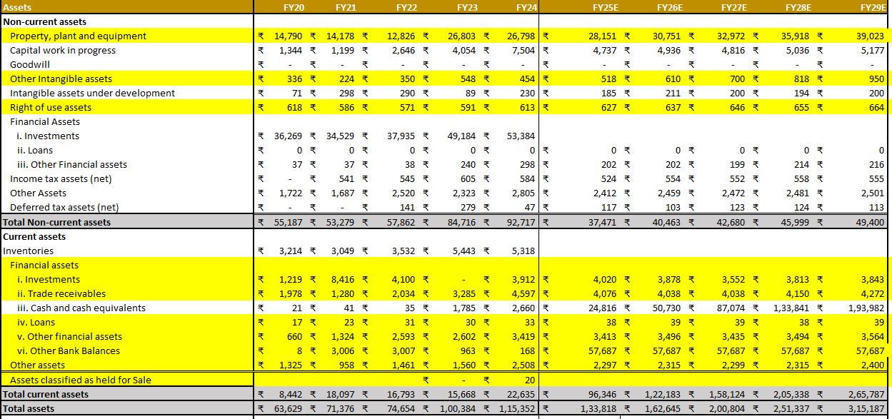
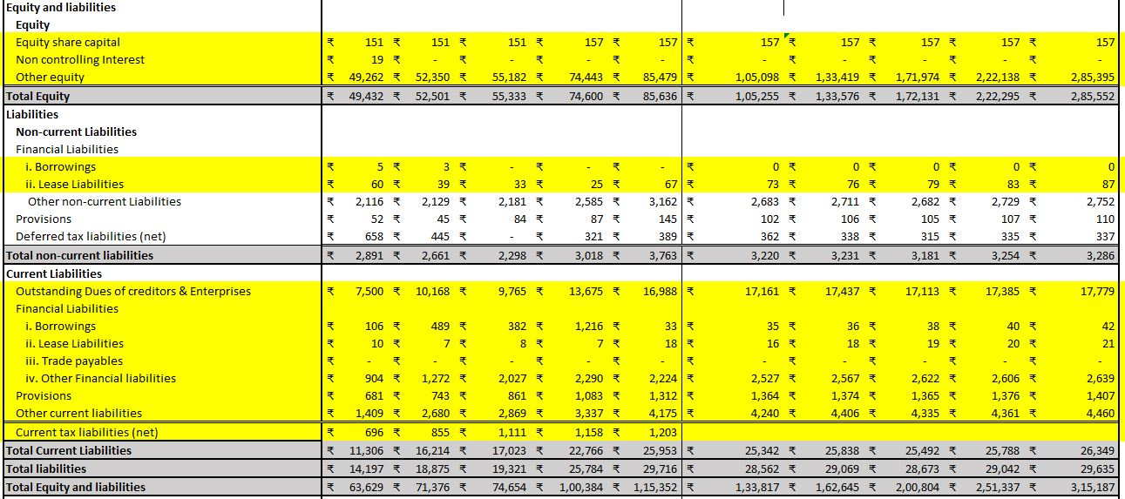
1. Analysis of Past Performance (FY20–FY24)
Analysis of Assets
Due to investments in property, plant, and equipment (PPE), non-current assets grew from ₹55,187 Cr in FY20 to ₹92,717 Cr in FY24.
Cash and cash equivalents increased significantly from ₹21 Cr (FY20) to ₹2,660 Cr.
(FY24), current assets climbed to ₹22,635 Cr from ₹8,442 Cr in FY20.
Total Assets: Increased from ₹63,629 Cr (FY20) to ₹1,15,352 Cr (FY24), demonstrating strong asset growth.
Analysis of Equity and Liabilities
Equity increased from ₹49,432 Cr in FY20 to ₹85,636 Cr in FY24, indicating capital appreciation and retained earnings.
Liabilities: Non-Current Liabilities demonstrated efficient long-term debt management as they went from ₹2,891 Cr to ₹3,7 63 Cr, a slight decline.
The main reason why current liabilities increased from ₹11,306 Cr (FY20) to ₹25,748 Cr (FY24) was the rise in trade payables and short-term obligations.
Total Equity & Liabilities: ₹1,15,352 Cr in FY24, aligned with asset growth.
2. Forecast for the Future (FY25E-FY29E)
Projected Assets
It is anticipated that higher investments in PPE, intangible assets, and deferred tax assets will increase by FY29, non-current assets are expected to total ₹1,49,400 Cr.
Current Assets: Increased cash reserves, investments, and trade receivables are expected to propel current assets to ₹2,65,187 Cr by FY29.
Total Assets: At a CAGR of about 19%, it is anticipated that total assets will surpass ₹3,15,187 Cr by FY29.
Projected Equity and Liabilities
By FY29, equity growth is expected to reach ₹2,85,552 Cr, demonstrating robust profitability and retained earnings.
Liabilities Outlook: ₹3,286 Cr is the expected level of non-current liabilities.
By FY29, current liabilities will reach 29,635 Cr, in line with corporate growth.
3. Key Takeaways & Strategic Outlook
Financial Stability: Maruti Suzuki's sound financial standing is demonstrated by a robust rise in assets and equity.
Low Debt Levels: A strong balance sheet is supported by less reliance on borrowing.
Strength of Cash Reserves: Liquidity is improved by notable growth in cash and investments.
Operational Growth: Growing PPE investments and trade receivables indicate aspirations for growth.
What is a Cash-Flow statement?
A cash-flow statement is a report of the company's cash management, which summarises all cash inflows that the company receives from its operations and investment sources, as well as cash outflows involved in the functioning of the business and investments, if any, by the company.
Cash-Flow of Maruti Suzuki (Last Five Years)
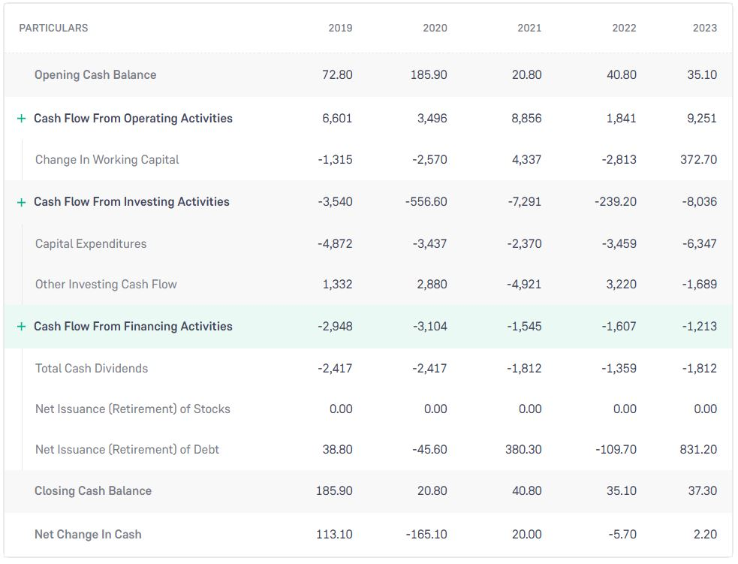

Revenue Model Forecasting & Analysis of Maruti Suzuki
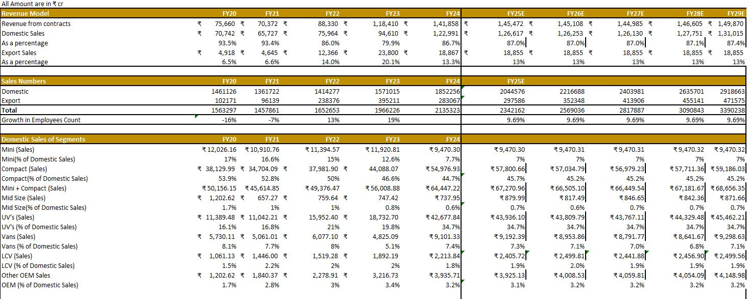
- Revenue Analysis: Revenue Growth: From ₹75,660 crore in FY20 to ₹1,41,858 crore in FY24, revenue from contracts has grown. This suggests robust growth.
Domestic vs. Export Sales: Although export sales have increased, they still make up a lesser percentage of total revenue, with domestic sales still accounting for about 87%.
Future Estimates: By FY29, the income is expected to have grown steadily to ₹1,49,870 crore.
- Sales Performance: Domestic Sales Growth: A strong growth in demand is demonstrated by the sales figures, which increased from 1.46 million units in FY20 to 1.85 million units in FY24.
Export Sales: Although they had a decline in FY21, export sales have increased dramatically since FY22.
Forecast: Starting in FY25, the company anticipates that total revenues will continue to expand by 9.69% annually.
- Segment-Wise Analysis: Compact cars continue to be the market leader, accounting for more than 40% of all domestic sales.
Utility Vehicles, or UVs, have grown significantly, rising from ₹11,389 crore in FY20 to ₹42,678 crore in FY24 alone.
Vans and LCV: They contribute less but are growing gradually.
- Employee Growth & Cost Considerations: Due to COVID-19, employee growth in FY20 and FY21, by 16% and 7%, respectively. There was a 19% growth in FY23,
indicating a rebound.
- Forecast & Growth Expectations (FY25-FY29): Projected Revenue Growth: From FY25 onwards, revenue growth is anticipated to be consistent at 3-4% per year.
Sales Volume: By FY29, it is anticipated that both domestic and export sales will have surpassed 3 million units.
Profitability: Profitability should continue to be high due to the stable domestic market and robust export demand.
Possible hazards include problems with the supply chain, changes in the price of raw materials, and a slowdown in the world economy.
Capex Schedule Forecasting & Analysis of Maruti Suzuki
(All Amount in Cr, unless stated otherwise)
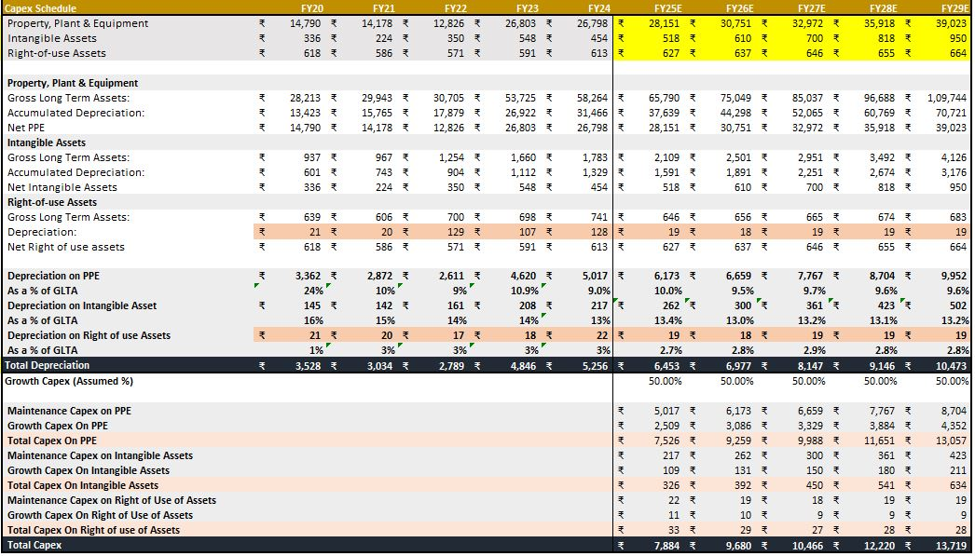
1. Capex Growth Trends
The property, plant, and equipment (PPE) sector grew from ₹14,790 Cr (FY20) to ₹26,798 Cr (FY24), according to the capex growth trends.
Projected to demonstrate steady growth, reaching ₹39,023 Cr by FY29.
In FY24, intangible assets increased from ₹336 Cr in FY20 to ₹454 Cr.
By FY29, it is anticipated to reach ₹1,026 Cr, reflecting a rise in R&D and software spending.
The Right-of-Use Assets saw a slight increase from ₹618 Cr in FY20 to ₹613 Cr in FY24, but otherwise remained largely steady.
By FY29, it is anticipated to increase slightly to ₹664 Cr.
2. Depreciation Trends
Depreciation overall:
grew from ₹3,528 Cr in FY20 to ₹5,256 Cr in FY24.
It is projected to rise to ₹10,473 Cr by FY29, suggesting higher asset utilisation.
PPE depreciation:
grew to ₹5,017 Cr in FY24 from ₹3,362 Cr in FY20.
By FY29, it is expected to reach ₹9,952 Cr, indicating a greater capital deployment.
Depreciation of Right-of-Use Assets and Intangibles:
These costs have increased along with assets.
Intangible asset depreciation makes for 14% of total intangible assets.
Depreciation on right-of-use assets is still between two and three percent.
3. Projections for Future Capex
Capex Total (Projected) grew to ₹13,719 Cr in FY29 from ₹7,884 Cr in FY25.
This implies ambitious plans for growth that include expenditures in R&D, technology, and new plants.
Growth in PPE Capex:
₹7,516 Cr in FY25 and ₹11,651 Cr by FY29, suggesting that production capacity increase is a priority.
Intangible Growth Capital Expenditure:
₹326 Cr in FY25, increasing to ₹756 Cr by FY29, indicating a greater emphasis on tech-based and digital solutions.
Capex for maintenance:
steadily increasing while maintaining the quality of current assets.
4. Key Takeaways
i) Robust Expansion Plans: Maruti Suzuki is investing a lot more in R&D and manufacturing capacity.
ii) PPE Growth Signals New Facilities: Increased capital expenditures point to the construction of new production facilities or the enlargement of current ones.
iii) Increased R&D and Digital Investment: Spending more on intangibles indicates a drive for digital technology and electrification.
iv) Sustained Depreciation Growth: Although asset utilisation is rising, short-term profitability may be impacted by rising depreciation expenses.
Debt Schedule Forecasting & Analysis of Maruti Suzuki
(All Amount in Cr, unless stated otherwise)
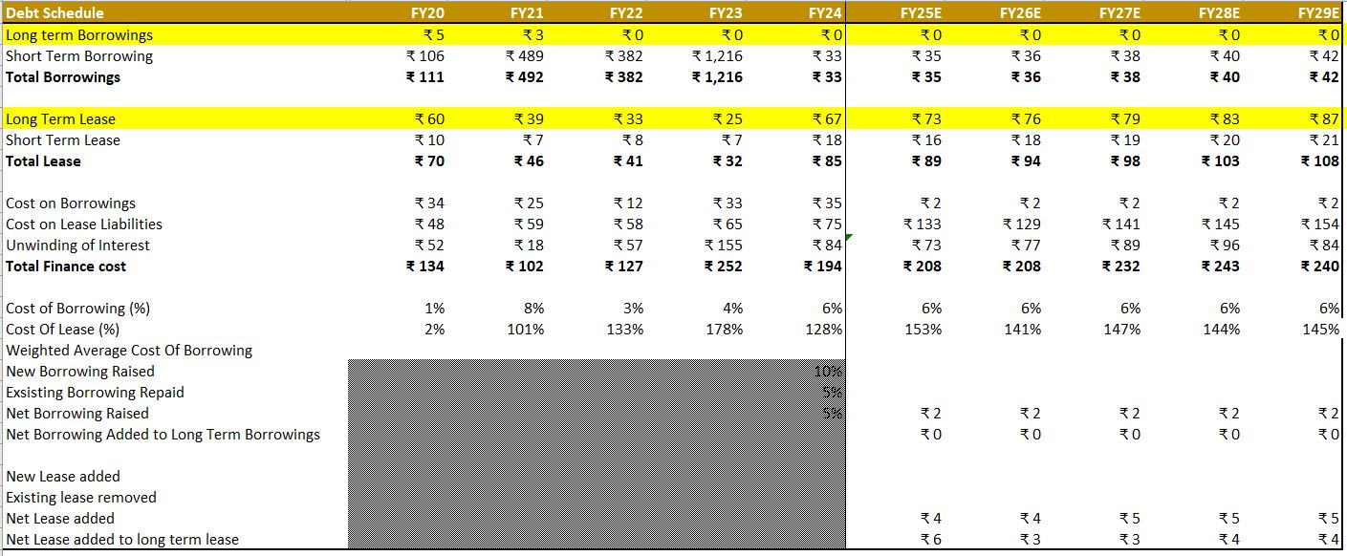
1. Borrowing Trend
Total amount borrowed: It decreased to ₹33 Cr in FY24 from ₹111 Cr in FY20.
By FY29, it is anticipated to stay low at ₹42 Cr, showing little reliance on debt funding.
Extended-duration Loans: It decreased to ₹0 Cr since FY22, suggesting a change in approach towards internal or equity funding.
Short-term Debt: It fell to ₹33 Cr in FY24 after reaching a peak of ₹1,216 Cr in FY23.
By FY29, it is anticipated to increase little to ₹42 Cr, indicating limited short-term funding needs.
2. Lease Liabilities Trend
All of the lease's obligations: It fluctuated between FY20 and FY24, going from ₹70 Cr to 85 Cr.
By FY29, it is anticipated to progressively increase to ₹108 Cr, indicating continued operating leases.
Extended Lease: It increased to ₹67 Cr in FY24 from ₹60 Cr in FY20.
With ongoing investments in leased properties or assets, it is anticipated to reach ₹87 Cr by FY29.
Temporary Lease: It grew to ₹18 Cr in FY24 from ₹10 Cr in FY20.
By FY29, it should have reached ₹21 Cr, indicating a moderate level of short-term leasing activity.
3. Finance Costs & Borrowing Rates
Total Cost of Financing: It fell to ₹194 Cr in FY24 after reaching a peak of ₹252 Cr in FY23.
By FY29, it is anticipated to stabilise at about 240 Cr, indicating managed borrowing costs.
Borrowing Cost (%): It raised to 6% in FY24 from 1% in FY20.
anticipated to stay around 6% till FY29, in line with growing risk premiums or interest rates.
Lease Cost (%):It raised to 6% in FY24 from 2% in FY20.
predicted to remain at 6% through FY29, suggesting a stable environment for leasing costs.
4. Key Takeaways
i) Minimal Debt Financing: Maruti Suzuki now relies more on internal funds and has shifted away from long-term borrowings.
ii) Managed Short-term Borrowing: Although short-term debt fluctuated, it is still within an acceptable range.
iii) Leasing Expansion Strategy: Growing lease commitments suggest that leasing is preferred over asset ownership.
iv) Stable Finance Costs: Although leasing and interest expenses have increased, they are still under control and are not anticipated to rise much.
Working Capital Schedule Forecasting & Analysis of Maruti Suzuki
(All Amount in Cr, unless stated otherwise)
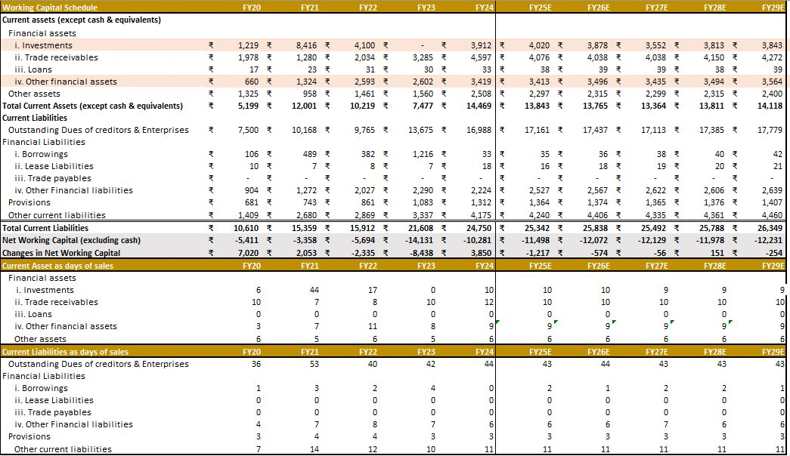
Capex Master Equations & Steps:
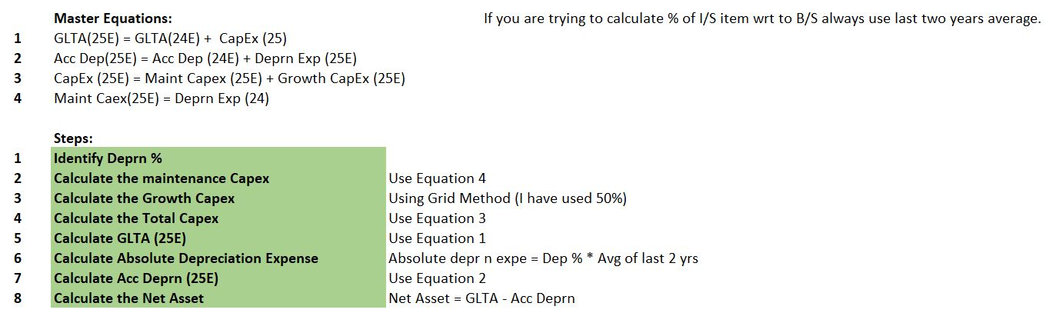
1. Current Assets Analysis
Total Current Assets (Cash and Equivalents Not Included):
grew to ₹14,469 Cr in FY24 from ₹5,199 Cr in FY20.
Between FY25 and FY29, it is anticipated to settle between ₹13,843 Cr and ₹13,811 Cr, indicating controlled asset growth.
Principal Forces Behind Asset Growth:
From ₹1,978 Cr in FY20 to ₹4,597 Cr in FY24, trade receivables increased dramatically and will continue to hover between ₹4,076 and ₹4,272 Cr till FY29.
Higher operational investments are shown by the fact that other financial assets doubled from ₹660 Cr in FY20 to ₹3,419 Cr in FY24.
2. Current Liabilities Analysis
Total Liabilities at Present:
grew to ₹24,750 Cr in FY24 from ₹10,610 Cr in FY20.
By FY29, it is expected to increase even more to ₹26,349 Cr, indicating a surge in short-term debt.
Important Factors Affecting Liability Growth:
Trade Payables: Showed lengthier payment timelines to suppliers, rising from ₹7,500 Cr in FY20 to FY24 at ₹16,988 Cr.
Financial commitments increased from ₹1,272 Cr in FY20 to ₹2,322 Cr in FY24, and by FY29, it should have stabilised at about ₹2,639 Cr.
3. Net Working Capital (NWC) Analysis
NWC (excluding cash): declining trend, reaching -₹5,694 Cr in FY22 and -₹8,438 Cr in FY23; improving to -₹3,850 Cr in FY24, demonstrating improved cash flow management; expected to stabilise between -₹1,217 Cr and -₹254 Cr from FY25-FY29, indicating stronger working capital efficiency;
Changes in NWC: significant negative impact of -₹8,438 Cr in FY23, implying major capital lock-up; expected to stabilise between -₹1,217 Cr and ₹151 Cr from FY25-FY29, easing operational strain.
4. Key Ratios & Efficiency Metrics
Trade Receivables: Showing consistent credit collection, they improved from 6 days in FY20 to 9 days in FY29.
Other Financial Assets: Showed operations with a high level of investment, increasing from 1 day in FY20 to 9 days in FY24.
Present Debt as Days of Sales:
Better supplier credit conditions are demonstrated by the increase in outstanding payables, which went from 36 days in FY20 to 44 days in FY24.
Other Liabilities: Showing steady liability management, stabilising at 11–12 days.
5. Forecast & Key Takeaways
i) Improving Working Capital Efficiency: Maruti Suzuki should stabilise its cash flows after a very negative NWC.
ii) Payables and Receivables Drive Growth: Rising trade payables and receivables show a dependence on supplier credit and longer collection periods.
iii) Sustainable Asset Growth: The working capital load is anticipated to decrease as asset growth slows down following a significant increase in current assets through FY24.
iv) Short-Term (FY24–FY26): Better financial flows and less demand on the NWC.
v) Long-Term (FY 27-FY29): Sound financials with effective working capital management (FY27–FY29).
WACC Schedule Forecasting & Analysis of Maruti Suzuki
(All Amount in Cr, unless stated otherwise)

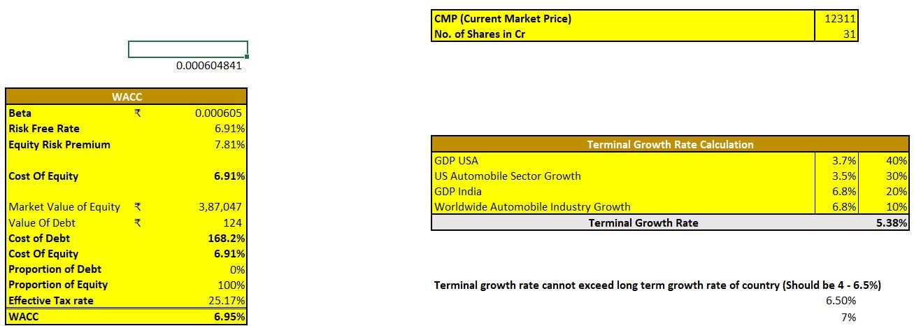
1. Cost of Capital Analysis
- Cost of Equity (6.91%)
Cost of Equity (6.91%)
Risk-Free Rate: 6.91%
Equity Risk Premium: 7.81%
Beta: Extremely low at 0.000605, indicating near-zero correlation with market movements.
- Cost of Debt (168.2%)
Seems unrealistically high, suggesting either an error in calculation or that the company is not relying on debt financing.
Since the proportion of debt is 0%, Maruti Suzuki is essentially debt-free.
- Weighted Average Cost of Capital (WACC): 6.95%
WACC is almost equal to the Cost of Equity (6.91%) because there is no debt in capital structure.
2. Analysis of Terminal Growth Rates
- Weighted Terminal Growth Rate: 5.38%, determined by
- The United States' GDP Growth (3.7%) - 40% Weight
- Growth of the US Auto Sector (3.5%) - 30%
- India's weight GDP growth (6.8%) -20%
- Weight Global Auto Industry Development (6.8%) – 10% Weight
The terminal growth rate stays between 4-6.5%, which is a viable long-term range.
3. Forecast & Outlook
i) Robust Equity-Based Capital Structure: Maruti Suzuki doesn't use any debt; it runs purely on equity.
ii) Low WACC Supports Higher Valuation: Future discounted cash flow (DCF) valuations will benefit from an advantageous cost of capital, which is indicated by a 6.95% WACC.
iii) Sustainable Long-Term Growth: The terminal growth rate of 5.38% is in line with both economic and industry trends.
iv) Short-Term (FY24–FY26): Consistently advantageous investment with a stable WACC of 6.9%–7%.
v) Long-Term (FY27–FY29): Persistent reliance on equity; the introduction of debt may cause WACC to further decline, improving valuation.
Free Cash Flow to Firm Schedule Forecasting & Analysis of Maruti Suzuki
(All Amount in Cr, unless stated otherwise)
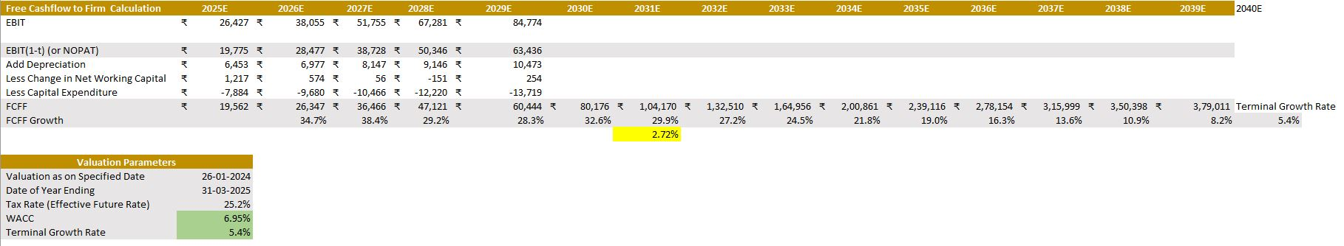
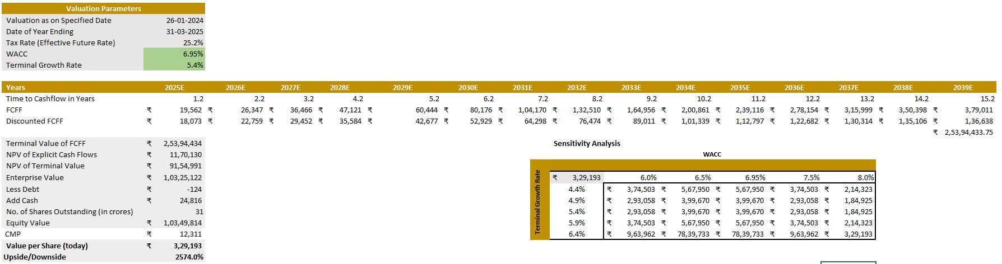
Formula Used: Enterprise Value = Equity Value + Debt Value – Cash
1. Working Capital Analysis
Net Working Capital (NWC): The NWC has been erratic, showing signs of liquidity pressure with a negative change in FY23 (-₹8,438 Cr). However, starting in FY24, the business appears to stabilise.
Trade Receivables & Payables: While trade payables are steady, trade receivables are rising, indicating robust revenue growth.
Current Liabilities: A persistent rise in unpaid debts and other financial obligations points to a potential need for funding as well as an expansion in operational scope.
Prediction:
With restricted working capital movements, anticipate a slow recovery in liquidity.
To prevent becoming overly reliant on short-term liabilities, the business needs to keep an eye on its payable cycle.
2. WACC & Capital Structure
For a car company, a WACC of 6.95% is appropriate since it balances risk and return.
At 6.91%, the cost of equity indicates a moderate perception of risk among investors.
Although the percentage of debt is zero, the cost of debt is incredibly high (168.2%), suggesting that the corporation is heavily financed by equity.
Prediction:
Financing based on equity is advantageous since it lowers interest costs.
WACC may increase if the business takes on debt in the future, which may affect valuation.
Consistent investor confidence is indicated by a moderate risk-free rate and a stable WACC.
3. Free Cash Flow to Firm & Valuation
For a car company, a WACC of 6.95% is appropriate since it balances risk and return.
Strong FCFF growth: By FY39E, it is anticipated to have increased from ₹19,562 Cr in FY25E to ₹3,79,011 Cr.
5.4% is a fair terminal growth rate that is in line with industry standards.
With an equity value of ₹1,03,49,814 Cr, the enterprise value (EV) is ₹1,03,25,122 Cr.
With the intrinsic value per share at ₹3,29,193 and the current market price (CMP) at ₹12,311, there is a huge 2574% upside.
Prediction: Maruti Suzuki is substantially undervalued in the market if these estimates come to pass.
Long-term financial stability is ensured by consistent FCFF growth.
If macroeconomic conditions stay constant, upside potential indicates high investor rewards.
4. Sensitivity Analysis
For a car company, a WACC of 6.95% is appropriate since it balances risk and return.
Regardless of the various WACC and Terminal Growth Rate scenarios, the value per share stays strong.
The share price is at ₹3,29,193 with a WACC of 6.95% and Terminal Growth of 5.4%.
The valuation is still high even with a higher WACC (8.0%) and slower growth (4.4%).
Prediction:
Long-term growth and variations in discount rates don't affect Maruti Suzuki's valuation.
Although the impact is not severe, valuation may decline if WACC rises considerably.
5. Key Insights & Forecasts
i) With consistent working capital, minimal debt, and excellent FCFF growth, Maruti Suzuki is a fundamentally sound company.
ii) Although market dynamics must be taken into account, massive undervaluation indicates tremendous investment opportunity.
iii) Although liquidity risks are declining, trade payables and cash flows still need to be watched.
iv) Sustaining high valuations will depend on future WACC stability.
Relative Valuation Forecasting & Analysis of Maruti Suzuki
(All Amount in Cr, unless stated otherwise)
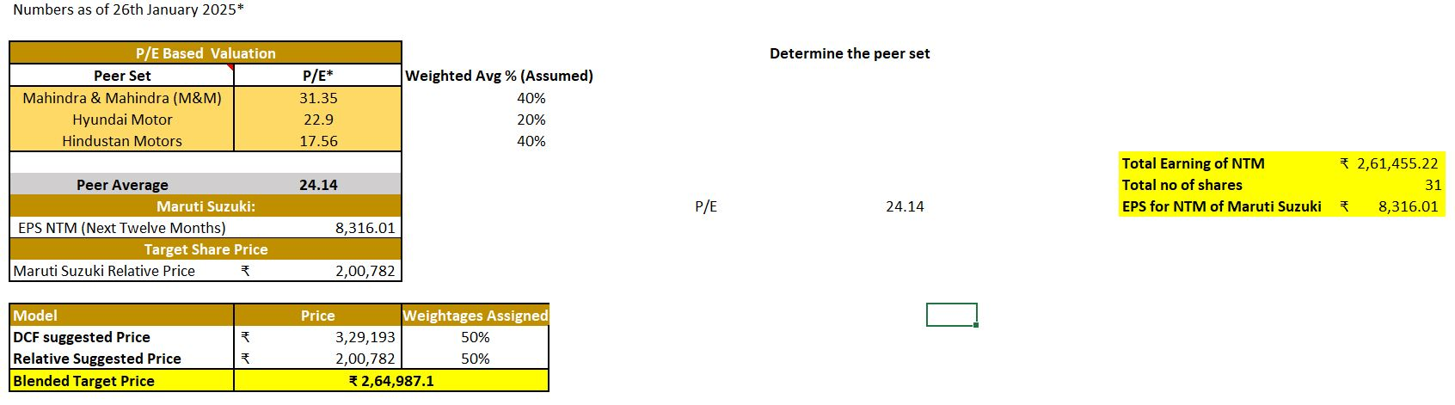
Valuation Peers Comparison (Last Five Years)
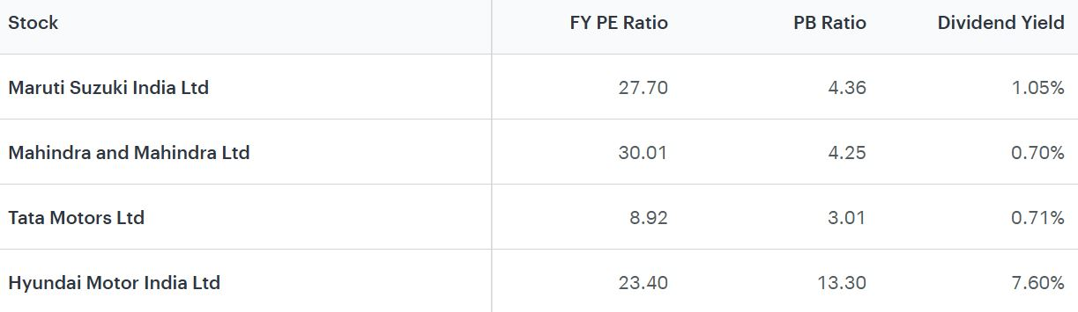
Relative Valuation
A greater valuation of ₹3,29,193 is suggested by the Discounted Cash Flow (DCF) model, but the Relative Valuation model estimates a target share price of ₹2,00,782. With a hybrid approach, both are given equal weight (50%) and the ultimate target price is ₹2,64,987.1.
1. Peer Comparison & P/E Based Valuation
i) With a weighted average P/E ratio of 24.14, the chosen peer group includes Hindustan Motors, Hyundai, and M&M.
ii) EPS: ₹8,316.01 for Maruti Suzuki (Next Twelve Months, NTM).
The implied relative price, calculated as P/E times EPS, is ₹2,00,782.
Forecast:
i) Maruti's P/E ratio might go higher if it sustains profits growth, which would support a possible upside.
ii) Maruti's valuation in relation to its rivals would be influenced by macroeconomic factors, interest rates, and the performance of the car industry.
2. Discounted Cash Flow (DCF) Valuation
An intrinsic value of ₹3,29,193 per share is suggested by DCF valuation, which is based on future Free Cash Flows to Firm (FCFF) and a WACC of 6.95%.
DCF vs. Relative Valuation Gap: Maruti may be undervalued in the market since its DCF valuation is much greater than its relative price.
The market price may rise to ₹3,29,193 if Maruti's anticipated future earnings growth is met.
Forecast:
i) Long-term investors may see significant potential if Maruti Suzuki maintains FCFF growth.
ii) However, profitability may be impacted by the EV transition, global recession risks, and competitive pricing.
3. Blended Target Price
Final Target Price: ₹2,64,987.1, with relative valuation and DCF given equal weight.
When compared to the current CMP of ₹12,311.4, this offers a huge gain.
4. Investment Outlook
i) Bullish Case: The valuation may get close to ₹3,29,193 if earnings growth keeps up.
Long-term profitability is ensured by steady WACC and FCFF growth.
Maruti may get closer to its DCF valuation if the market re-rates.
ii) Bearish Case: Earnings may be impacted by a slowdown in auto demand or fierce EV rivalry.
Disruptions to the global supply chain may put pressure on profitability.
The market might stay closer to the relative valuation of ₹2,00,782 if investors exercise caution.
Financial Ratios of Maruti Suzuki
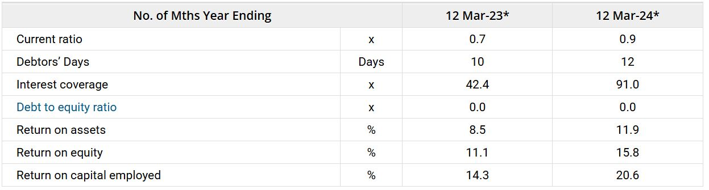

Solvency Ratios
Current Ratio: The company's current ratio improved and stood at 0.9x during FY24, from 0.7x during FY23. The current ratio measures the company's ability to pay short-term and long-term obligations.
Interest Coverage Ratio: The company's interest coverage ratio improved and stood at 91.0x during FY24, from 42.4x during FY23. The interest coverage ratio of a company states how easily a company can pay its interest expense on outstanding debt. A higher ratio is preferable.
Profitability Ratios
Return on Equity (ROE): The ROE for the company improved and stood at 15.8% during FY24, from 11.1% during FY24. The ROE measures the ability of a firm to generate profits from its shareholders capital in the company.
Return on Capital Employed (ROCE): The ROCE for the company improved and stood at 20.6% during FY24, from 14.3% during FY23. The ROCE measures the ability of a firm to generate profits from its total capital (shareholder capital plus debt capital) employed in the company.
Return on Assets (ROA): The ROA of the company improved and stood at 11.9% during FY24, from 8.5% during FY23. The ROA measures how efficiently the company uses its assets to generate earnings.
Discussion
Growth Opportunities:
1. Electric Vehicle (EV) Market Expansion
Current Scenario:
i) In contrast to rivals like Tata Motors and MG Motors, Maruti Suzuki has been sluggish to enter the EV industry.
ii) The company intends to invest more than ₹10,000 crore in EV infrastructure in order to deploy its first EV (EVX) by 2025.
Growth Opportunities in EVs:
i) Future EV Lineup & Models:
By 2030, Maruti Suzuki intends to introduce six EV vehicles to appeal to Indian consumers on a tight price.
Utilise the R&D of parent business Suzuki to concentrate on mass-market, reasonably priced EVs.
ii) Battery & Charging Infrastructure:
Competitiveness is increased through a partnership with Toyota for EV and hybrid technologies.
Cost-effective battery solutions will be offered by Suzuki's battery gigafactory in Gujarat.
infrastructure expansion for charging with assistance from the government.
iii) Government Support & Incentives:
EV adoption in India is increased by the FAME-II initiative and PLI subsidies.
Maruti stands to gain from lower GST (5%) on EVs and battery production subsidies.
iv) Price-Sensitive Market Strategy:
With over 40% of the market, Maruti is the market leader in the small car and compact SUV segments.
EVs that are reasonably priced (less than ₹10 lakh) may greatly encourage widespread adoption.
Global Market Expansion:
Current Scenario:
i) Although exports are increasing, Maruti Suzuki's primary focus is India.
ii) Strong presence in SAARC countries, Latin America, and Africa.
iii) Little environmental impact in the US and Europe because to strict safety and emission standards.
Growth Opportunities in Market Expansion:
i) Emerging Markets Focus (Africa, Latin America, ASEAN)
Maruti's strengths are in line with the growing demand for reasonably priced cars in emerging regions.
Exports may be boosted by expansion into Latin America, Vietnam, and Indonesia.
ii) Leveraging Suzuki’s Global Network
Suzuki's global reach in Europe and Japan can aid Maruti's foray into high-end hybrids and tiny automobiles.
Costs could be lowered by local assembly plants in Latin America and Africa.
iii) Hybrid & Alternative Fuel Strategy
Models based on ethanol, CNG, and hybrids may be essential for growth in areas where EV adoption is sluggish.
Flex-fuel vehicles (FFV) may facilitate entry into Southeast Asia and Brazil.
iv) Exports to Established Markets (Australia, Europe)
Suzuki and Toyota's EV partnership could pave the way for EV exports to wealthy nations.
Maruti may be able to compete in Europe with improved safety regulations and electrification.
2. Technology & Cost Efficiency:
Current Scenario:
i) Maruti Suzuki is renowned for its economical manufacturing and fuel economy.
ii) Less money spent on automation, AI, and digital automotive technology than competitors worldwide.
Growth Opportunities in Technology & Cost Optimization:
i) Industry 4.0: AI and Smart Manufacturing
Use of robotics, IoT, and AI in manufacturing to increase output.
Lean manufacturing and supply chain automation can cut expenses by 10% to 15%.
ii) Digital Features & Connected Car
Growing desire for linked features, ADAS (Advanced Driver Assistance Systems), and smart infotainment.
Incorporating Suzuki's international technology partnerships for enhanced safety and autonomous driving technologies.
iii) Cost Efficiency in EV Battery Manufacturing
EV costs will be greatly reduced by locating battery manufacture in India (at Suzuki's Gujarat Gigafactory).
EV battery recycling and the usage of second-life batteries can increase profits.
iv) Hybrid Technology as an Affordable EV Substitute
Before EV adoption reaches its full potential, strong hybrid models (like Toyota's hybrid technology) could provide fuel savings of 30–40%.
Fuel-conscious Indian consumers who are wary about EV charging infrastructure are the target market for hybrid vehicles.
Challenges & Risks:
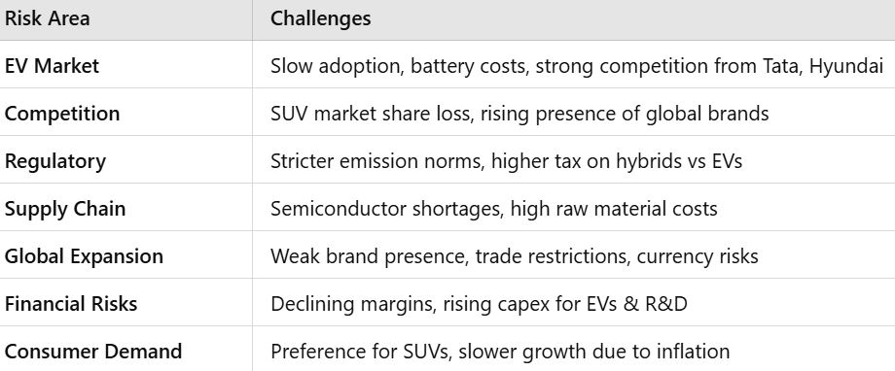

Summary
Maruti Suzuki continues to dominate the passenger car market in India thanks to its stable finances, robust dealer network, and cost-effective manufacturing. But in the SUV and EV markets, where Tata, Hyundai, and others are capturing market share, it is up against more competition.
Long-term growth potential is provided by the company's hybrid strategy with Toyota and international expansion initiatives, but its premium market weakness and glacial EV adoption continue to be major obstacles.
Strong upside potential (~2574%) is suggested by valuation, however there are short-term dangers because of supply chain problems, competition, and changing consumer preferences. Maruti's global expansion plan, hybrid push, and cost leadership may eventually result in long-term, sustainable profits.
Conclusion: Bullish (long term), neutral to slightly bearish (short term).
Appendices
References:
- https://www.marutisuzuki.com/?srsltid=AfmBOorTYXfsQ_L2IXaVvFlOKNCSjvF6NCnXpwdM0Eiv6-_75cb4hPX7
- https://www.marutisuzuki.com/corporate/investors/company-reports?srsltid=AfmBOopV82cZh-sIMfP1Q62g2Y8IUNB_eis6hFGH0GMpNr1PPywBDkMb
- https://www.moneycontrol.com/financials/marutisuzukiindia/profit-lossVI/ms24
- https://alvronpartners.com/
- https://www.screener.in/company/MARUTI/consolidated/#peers

Plagiarism Report:
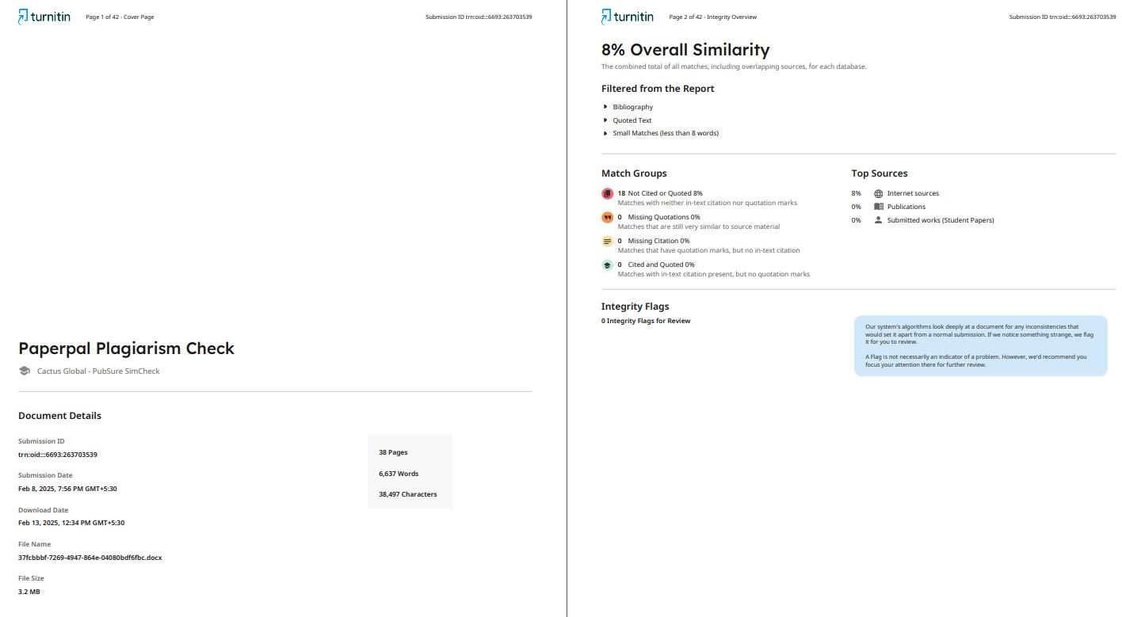
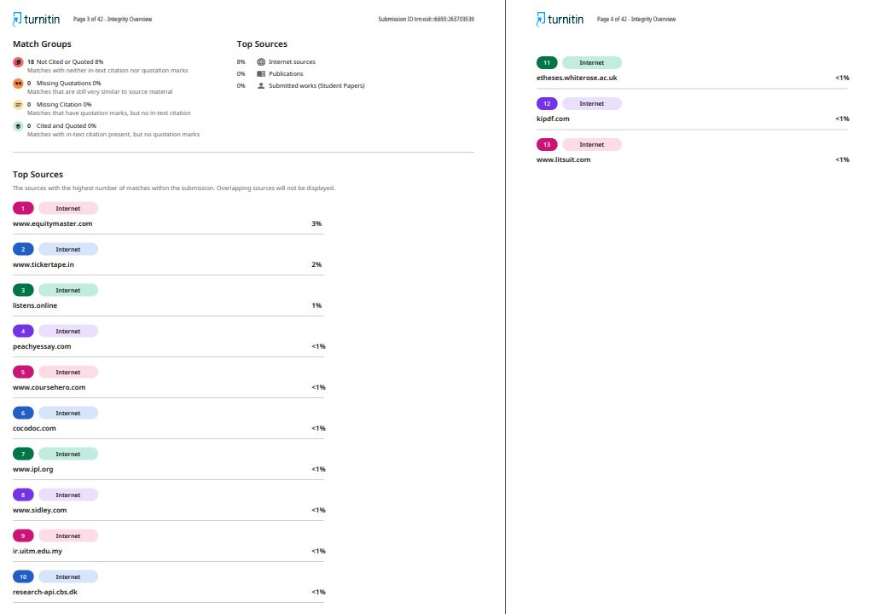
AI Report:
